ARTICLE TYPE:
Islamic Work Ethics affect the employee Performance; case study of several universities in Indonesia

Muhammad Azizi¹

Management¹, University Of Tomakaka, Mamuju, Indonesia
∗Author to whom any correspondence should be addressed.

HISTORY |  | ABSTRACT
RECEIVE:  19 May 2025  REVISED :  28 May 2025  ACCEPTED :  08 June 2025 |  | Design/methodology/approach: This paper selects a case study with a purposive random sampling technique, with the status of permanent employees, at Islamic universities in East Java City, Indonesia, namely: UNISMA, UIN, UMM who have worked for a span of one year. Data is completed from questionnaires, interviews. The data analysis method used in this research is multiple linear regression analysis using SEM-AMOS.  Purpose: The purpose of this study is to find out a causal relationship between Islamic work ethics and why the performance of Islamic higher education employees can occur. This study aims to broaden the understanding of Islamic human resources and related aspects of Islamic ethics more broadly than usual. This study proposes a description of each concept.  Findings: This research contributes to Islamic universities in Indonesia with various elements in it having a high work ethic in carrying out roles and functions to improve employee performance. The implications of this study indicate that a healthy competitive attitude and having a character or culture of helping each other will make employee performance better.  Research limitations/implications: Because the research approach has limitations. It is recommended that the next model approach is different from this research to obtain in-depth data so that a more comprehensive picture is obtained. In addition, helping each other will make employee performance better.  Keywords: Islamic work ethics; Employee perception; Islamic Education
DOI:

- Introduction
Universities with various elements that exist within it, just as the existing members of the college have high work ethics in performing its role and function optimally as a form of responsibility of the education personnel as well as the most important thing is a form of human responsibility towards Allah SWT who have run the mandate well And optimal. The low work ethics will have an impact on the institution and the quality of graduates which is currently the central issue of higher education (quality assurance). Universities have a very strategic role in order to produce quality human resources. This strategic role is in line with the purpose of higher education that is preparing learners to become members of the community who have academic and / or professional skills that can apply, develop and / or enrich the treasury of science, technology and / or art. Several studies were conducted in analyzing the work ethic which was mostly done in America and Europe, using Max Weber's views expressed in his research on Work Ethical Protestant ethics that there is a causal relationship between Protestant work ethic and the development of capitalism in Western society [1].
The findings are very contrary to the concept of Islamic Work Ethical (Islamic Work Ethical) derived from Al-Qur'an and the words and actions of the Prophet Muhammad (Al-hadith). Rasulullah SAW said that work done with hard work causes the sins to be forgiven and that no one eats better food than the food produced from his work. In the Qur'an Allah says: "Work, then the Lord and those who believe will see your work, and you will be returned to (God) who knows the invisible and the real, and then tell you what you have done Surah At-Taubah: 105). In this case, it becomes a foundation for us about the importance of work and the necessity to do so. However, looking at the phenomenon described above, where there is a shift in one's orientation when working is more to orientation to find meaning for his work. So it takes a tool to achieve it. Previous studies conducted by [2] provide evidence that the work ethic of Islam has a significant effect on the performance of hospital employees owned by the government and national banks in Pakistan. The findings are similar to the research conducted by [3] that the value of the work ethic of Islami significantly influences the company's ability to innovate and the company's performance.
- Literature Review and Hypothesis Development
A. Islamic Work Ethic to employee performance
Work Ethics in Islamic perspective is defined as a radiance derived from the Islamic belief system that is, as a basic attitude of life with regard to work [4]. Islamic work ethic is an obligatory activity to address the needs of human life to build a balance of social and individual life. If every individual has a desire to work hard by promoting cooperation, ultimately the desire for a happy life can be achieved because working with hard work, high commitment and promoting cooperation is a noble deed [5]. Ethics is a set of moral practices that distinguish between right and wrong [6]. This means, ethics deals with values, good living arrangements, good living rules and all habits that are shared and passed from one person to another or from one generation to another. This habit is then revealed in the patterned behavior that continues to recur as a habit, [7]. [8] says that the essence of religion lies in man, religion is a physical projection of man. So [9] “explain there are seven dimensions of work ethic of Islam that is, Work intention, Trusteeship, Work type, Work for Islamic Ummah, Justice & Fairness, Cooperation & Colaboration and Work as the only source of ownership. Islamic work ethics see the goal of working not as a mere completion of work, but to encourage personal growth and social relations [10]”.
Performance is seen as a process or a result of work, where performance is a process of how the work takes place to achieve the work, [11]. Individual / occupational performance is an achievement or effectiveness at the employee or job level. Performance at this level is influenced by job goals, job design and job management as well as individual characteristics [11]. States that there are several ways to measure the performance of employees in general, namely; 1) quantity of work 2) quality of work 3) knowledge of work 4) opinions or questions submitted 5) decisions taken 6) work planning 7) area of work organization. Thus the performance pertains to the results of work achieved by a person within a certain period of time measured by quantity and quantity. The job performance standard determines the level of job performance expected from the job holder and the criteria to what extent job success is measured. The job performance standards make explicit the quantity and quality of performance expected in the basic tasks defined earlier in job descriptions, usually through some questions that are considered acceptable and achievable for a particular job. As the Word of God in surah At-Taubah (9): 105. Meaning: And say: "Work thou, then God and His Messenger and the believers will see thy work, and ye shall be restored unto (God) who knoweth the unseen and the real, and then proclaim unto you what has You do. To gain a clear understanding of the Islamic work ethic and its dimensions, According to [12], Muslim work ethic has several characteristics including. Therefore, a hypothesis was developed, as follows:
H1 : Al-Shalah has a significant effect on employee performance Islamic College
Al-Shalah or good and useful that comes from the sincerity of the intention of the performer and the work that has the values of goodness. The absolute requirement that must be possessed of a job to be said Al-Shalah that is, that work is based on sincerity and intention for good as commanded in Al-Qur'an and Al-Hadith. Islam is only ordered to carry out good and beneficial work for humanity so as to improve the quality of life / human level in the eyes of Allah SWT, as described in the Qur'an (Surat al-An'am: 132). Meaning: ”And each person obtains degrees (balanced) with what he does. And your god is not unmindful of what they do ". Previous studies conducted by [13] provide evidence that the work ethic of Islam has a significant effect on the performance of hospital employees owned by the government and national banks in Pakistan. The findings are similar to the research conducted by [14] that the value of the work ethic of Islami significantly influences the company's ability to innovate and the company's performance.

H2 : Al-Itqan has a significant effect on employee performance Islamic College
Al-Itqan or steadiness, Itqan's work quality is the result of work that can achieve ideal job standards technically. For that required knowledge support and skill (competence) is optimal. Islam advocates his followers to continue to increase or develop their knowledge and still train and develop themselves to be able to work professionally so that the results obtained are the result of quality work / quality of Islamic work as mentioned in the Qur'an (Surah An-Naml: 88). Meaning : “And you see the mountains, you think He is still in place, when he walked as a way of clouds. (That is) the act of God that makes with the root of every thing; Allah is well acquainted with what you do. "The quality of Islamic work is described in the words of Prophet Muhammad narrated by Thabrani, which means: "Indeed Allah is very loving if a person does a work he does with Itqan or perfect (professional)." (Narrated by Thabrani). Previous studies conducted by [15] The impact of Islamic work ethics on employee performance: testing two models of personality x and personality y. This study discusses the relationship of work ethic of Islam with employee performance and tested the two models of work personality X and personality Y
H3 : Al-Ihsan has a significant effect on employee performance Islamic College
Al-Ihsan or do the best and better. Tasmara (2008), Ihsan quality can be explained as follows: First, Ihsan is articulated as the best of which can and has been done. Ihsan's meaning has similarities with Itqan. The meaning of Ihsan that Muslims are committed to him to produce the best job / work in every activity. Second, Ihsan has a better meaning than the achievement or quality of previous work. This meaning gives the message of continuous improvement, along with increasing knowledge, experience, time, and other resources. A disadvantage if today's work performance declined from yesterday. The concept of Al Ihsan is explained in the Qur'an (Q.S. An-Nahl: 90). Meaning : "Allah hath commanded (you) to be just and do good, give unto the kin, and Allah forbid from the abominations, and enmities. He teaches you to take lessons”. The findings are similar to the research conducted by [16] that the value of the work ethic of Islami significantly influences the company's ability to innovate and the company's performance
H4 : Al-Mujahadah has a significant effect on employee performance Islamic College
Al-Mujahadah or hard work optimally. Allah SWT commands to work hard / diligently in performing a job so that optimal results can be achieved, in the Qur'an (Surah al-Insyirah: 7-8). Meaning: “Then when you are finished (of a matter of affairs), do earnestly (affairs) other, And only to your God you should expect". Previous studies conducted by [17] provide evidence that the work ethic of Islam has a significant effect on the performance of hospital employees owned by the government and national banks in Pakistan.
H5 : Tanafus and Ta'awun has a significant effect on employee performance Islamic College
Tanafus and Ta'awun or compete and help each other. Competing to the good is one of representations of Tanafus and Ta'awun. Word of Allah SWT in Al-Qur'an (Surah al-Baqarah: 148). Meaning: "And for every people there is a mecca (self) which he faces to him. So race (in making) goodness. Wherever you are, Allah will gather you all (on the Day of Resurrection). Verily Allah is All-Powerful over all things ". The result of this study are in line with previous research conducted by [18] Islamic work ethics to the relationship locus of control with employee performance. In the research shows the influence of Islamic work ethics negatively on the relationship between locus of control and employee performance. The coefficient of interaction with negative significance with p significance of 0.014 (p <0.05) implies that Islamic work ethic is a moderating variable in which the work ethic of Islam weakens the relationship between locus of control and employee performance. This, careful management of the work ethic of Islam on employees in relation to the perception of the locus of control to improve its performance. [19] The influence of the Islamic work ethos and the transformational leadership style of organizational commitment and employee performance. [20] The study concludes that the Islamic work ethic and transformational leadership style have a positive and significant impact on organizational commitment and employee performance, and organizational commitment mediates the influence of transformational leadership styles on employee performance. [21] The influence of Islamic work ethics on employee performance. This test uses two models. This study discusses how the relationship between Islamic work ethics and employee performance. [22] The test was carried out using a statistical structural equation model and it resulted that Islamic work ethics had a significant effect on employee performance. [23] Then the results of the study show that Islamic work ethics affects employee performance. Furthermore, the results show how Islamic work ethics can add insight and knowledge to employee performance. Religion Islam advocates a good and rewarding work for humanity, so that every job can add value and elevate the human level both individually and in groups. As the Word of God in Surah An-Nahl verse 97: Meaning: ”Whoever says good deeds, both men and women in a state of faith, then we will actually give him a good life and we will indeed reward them with a better reward from what they have done”.
Figure 1. Conseptual Hipotesis
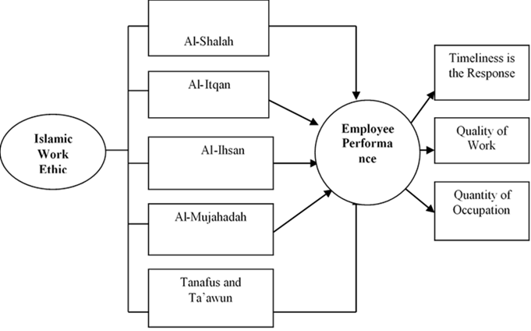

- Research Method
This study employs an explanatory research design, aiming to analyze the causal relationships among key organizational variables within Islamic higher education institutions. The research relies on primary data collected directly through a structured questionnaire, designed to capture respondents’ perceptions regarding the studied constructs.
The population in this research consists of permanent employees working at Islamic universities in Malang City, including Universitas Islam Malang (UNISMA), Universitas Islam Negeri Maulana Malik Ibrahim (UIN Malang), and Universitas Muhammadiyah Malang (UMM). These institutions were selected because they represent leading Islamic higher education organizations with established administrative and academic structures. Respondents were eligible to participate if they had been employed for at least one year, ensuring sufficient familiarity with institutional culture and management practices.
The sampling technique applied in this study was purposive random sampling (Sugiyono, 2019), allowing the researcher to select respondents who met specific inclusion criteria related to employment status and experience. A total of 120 valid questionnaires were collected and analyzed after data screening for completeness and consistency.
The instrument used a five-point Likert scale (ranging from 1 = strongly disagree to 5 = strongly agree) to measure each variable. The questionnaire items were adapted from previous validated studies and adjusted to the Islamic higher education context. A pilot test was conducted to ensure the reliability and clarity of the instrument prior to full data collection.

The data analysis method used in this research is multiple linear regression analysis, processed through SPSS version 23.0 (Statistical Product and Service Solutions). This method was chosen to test the influence of independent variables on the dependent variable simultaneously. Before hypothesis testing, classical assumption tests—including normality, multicollinearity, and heteroscedasticity—were conducted to ensure the validity of regression results. Statistical significance was determined at the 5% level (α = 0.05). This analytical approach allows the researcher to explain the degree and direction of influence among variables and provides empirical evidence of causal relationships within the organizational setting of Islamic universities in Malang.
- Result and Discussion
In this sub-chapter will be explained in a row will describe the variable variable of Islamic Work Ethic (X) with some sub-variables of Al-Shalah, Al-Itqan, Al-Ihsan, Al-Mujahadah, Tanafus and Ta'awun, and Employee Performance variables (Y) consisting of Timeliness, Performance Quality, Performance Quality, and Quality of work.
A. Islamic Work Ethic (IWE) effect on employee performance
The number of questionnaires to extract data on the Islamic Work Ethic consists of 10 items of questions covering Al-Shalah (Q1 and Q2), Al-Itqan (Q3 and Q4), Al-Ihsan (Q5 and Q6), Al-Mujahadah (Q7 and Q8), Tanafus and Ta'awun (Q9 and Q10). While the number of respondents as many as 15 respondents for each research object, so the total respondents are 45 respondents with a maximum value of 5 and at least 1. Based on the data used, the value for the lowest islamic work ethic is 10 and the highest is 50. Thus, the range is obtained from the difference between the highest and lowest Islamic work ethic value, which is 50 - 10 = 40. Based on the range, Interval class is determined is 5, it can be seen that the length of the interval class is 40: 5 = 8. The following is the presentation of the frequency distribution data of each indicator of the Islamic work ethic :
Al-Shalah effect on employee performance
The first indicator is Al - Shalah or Good and Beneficial. The number of question items is two questions that include 1) good work will benefit yourself and others, 2) good relationships between colleagues and superiors is a top priority in work. The results of frequency distribution analysis of this indicator is presented in table 1 as follows.
Table 1. Frequency Distribution of Work Ethics (Al – Shalah)
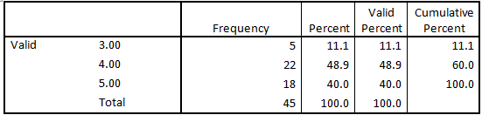
Based on table 1, it can be seen that the respondents who stated strongly agree as many as 18 respondents (40%), agreed as many as 22 respondents (48.9%), and declared neutral as much as 5 respondents (11.1%), while respondents who disagree And strongly disagree as much as 0 respondents.
Respondents who are employees at the university of Islam (Unisma, UIN, UMM) responded strongly agree that the indicator of Al-Shalah (Good and Beneficial) describes the work ethic of Islam. This can be interpreted that in general employees at Islamic universities located in the city of Malang considers that establishing good and beneficial relationships to each colleague or superior is the work ethic. Previous studies conducted by Haroon et al. (2012) provide evidence that the work ethic of Islam has a significant effect on the performance of hospital employees owned by the government and national banks in Pakistan. The findings are similar to the research conducted by [21] that the value of the work ethic of Islami significantly influences the company's ability to innovate and the company's performance.
Al-Itqan effect on employee performance
The second indicator is Al - Itqan or quality work. The number of question items are two questions that include 1) The quality of work is your principle in the work, 2) The quality of work achievement is done with maximum effort. The results of frequency distribution analysis of this indicator is presented in table 2 as follows:
Table 2. Frequency Distribution of Islamic Work Ethics (Al – Itqan)
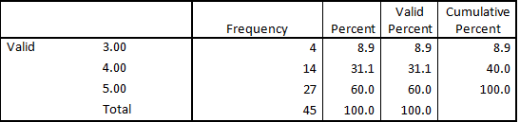
Based on table 2, it can be seen that the respondents stated strongly agree as many as 27 respondents (60%), agreed as many as 14 respondents (31.1%), and stated neutral as many as 4 respondents (8.9%), while respondents who disagree And strongly disagree as much as 0 respondents. Respondents who are employees at the university of Islam (Unisma, UIN, UMM) responded strongly agree that the Al-Itqan indicator (the work of quality) describes the work ethic of Islam. This can be interpreted that in general employees at Islamic universities in the city of Malang assume that a good work ethic is the work of quality. Previous studies conducted by the findings are similar to the research conducted by [17] that the value of the work ethic of Islami significantly influences the company's ability to innovate and the company's performance.
Al-Ihsan
The third indicator is Al - Ihsan or the best work. The number of question items are two questions that include 1) Difficulties in life can be overcome by creating the best work, 2) All the abilities have been devoted to create the best work. The results of frequency distribution analysis of this indicator is presented in table 3 as follows.
Table 3 Frequency Distribution of Work Ethics (Al – Ihsan)
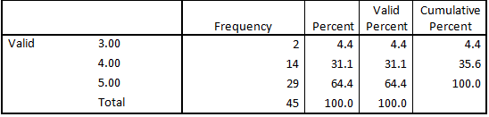
Based on table 3, it can be seen that the respondents stated strongly agree as many as 29 respondents (64.4%), agreed as many as 14 respondents (31.1%), and stated neutral as much as 2 respondents (4.4%), while respondents who disagree And strongly disagree as much as 0 respondents. Respondents who are employees at the university of Islam (Unisma, UIN, UMM) responded strongly agree that the indicators of Al-Ihsan (best work) able to describe the Islam Work Ethic. This can be interpreted that in general employees at Islamic universities in the city of Malang consider good work is a measure in measuring work ethic. Previous research conducted by [12] The impact of Islamic work ethics on employee performance: testing two models of personality x and personality y. This study discusses the relationship of work ethic of Islam with employee performance and tested the two models of work personality X and personality Y
Al-Mujahadah
The fourth indicator is Al - Mujahadah or working hard. The number of question items are two questions that include 1) Hard work to ensure success in work, 2) Hard work done on the basis of responsibility. The results of frequency distribution analysis of this indicator is presented in table 4 as follows.
Table 4. Frequency Distribution of Islamic Work Ethics (Al – Mujahadah)
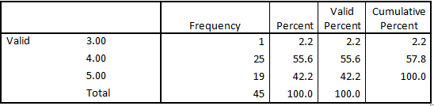
Based on table 4, it can be seen that the respondents stated strongly agree as many as 19 respondents (42.2%), agreed as many as 25 respondents (55.6%), and stated neutral as much as 1 respondent (2.2%), while respondents who disagree And strongly disagree as much as 0 respondents. Respondents who are employees at the university of Islam (Unisma, UIN, UMM) gave a strongly agreed response to the Al-Mujahadah indicator (working hard) able to describe the work ethic of Islam. This can be interpreted that in general employees at Islamic universities in the city of Malang consider the work ethic assessment can be seen from the attitude to always work hard. Previous studies conducted by the findings are similar to the research conducted by [7] that the value of the work ethic of Islami significantly influences the company's ability to innovate and the company's performance.
Tanafus dan Ta’awun
The fifth indicator is Tanafus and Ta'awun or compete and help each other. The number of question items are two questions that include 1) Cooperation provides benefits and satisfaction in work, 2) Give appreciation to the competition among colleagues to improve the quality of work. The results of frequency distribution analysis of this indicator is presented in table 5 as follows.
Table 5. Frequency Distribution of Work Ethics (Tanafus dan Ta’awun)
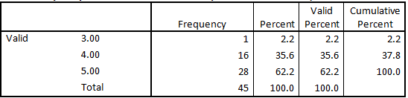
Based on table 5, it can be seen that the respondents stated strongly agree as many as 28 respondents (62.2%), agreed as many as 16 respondents (35.6%), and stated neutral as much as 1 respondent (2.2%), while respondents who disagree And strongly disagree as much as 0 respondents. Respondents who are employees at the university of Islam (Unisma, UIN, UMM) responded strongly agree to indicator Tanafus and Ta'awun (competing and helping each other) in describing the work ethic islami . This can be interpreted that in general employees at Islamic universities in the city of Malang assume that the work ethic of Islam can be seen from indicator Tanafus and Ta'awun. Previous studies conducted by [3] provide evidence that the work ethic of Islam has a significant effect on the performance of hospital employees owned by the government and national banks in Pakistan.
B. Employee Performance (EP)
The number of questionnaires to dig data about the performance of employees as much as 6 items consisting of 3 indicators of Time Accuracy, Quality of Work and Quantity Work. The number of respondents is 45 respondents consisting of 15 respondents from UIN, 15 respondents from Unisma and 15 respondents from UMM. The highest score of the employee performance questionnaire is 5 and the lowest 1. Thus, the range can be obtained from the difference between the highest and lowest values of 30 - 6 = 24. Based on the range, with the number of interval classes determined is 5, it can be seen that the length of the class The interval is 24: 5 = 4.8. Based on the lowest and highest values and the length of the interval class, it can be arranged frequency distribution. The following is the frequency distribution table 1) Timeliness, 2) Work Quality, and 3) Quantity Work.
Time Accuracy
The first indicator of employee performance is timeliness. The number of question items are two questions that include 1) The task given to me, I can finish on time, 2) Every job I have to finish in time. The results of frequency distribution analysis of this indicator is presented in table 6 as follows.
Table 6. Frequency Frequency Distribution Time
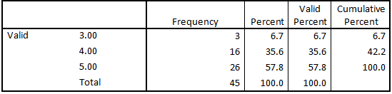
Based on table 6, it can be seen that respondents who stated strongly agree as many as 26 respondents (57.8%), agreed as many as 16 respondents (35.6%), and stated neutral as much as 3 respondents (6.7%), while respondents who disagree and strongly Not agree as much as 0 respondents. Therefore it can be concluded that the respondents who are employees at the university of Islam (Unisma, UIN, UMM) responded strongly agree that the indicators of timeliness is a benchmark of employee performance. This can be interpreted that in general employees in Islamic universities located in the city of Malang considers that a good performance is a performance that can be completed on time.
Work Quality
The second indicator of employee performance is the quality of work. The number of question items are two questions that include 1) The process of completion of work that I do in accordance with the standards of the bank, 2) The results of my work really qualified. The results of frequency distribution analysis of this indicator is presented in table 7 as follows.
Table 7. Frequency Distribution of Work Quality
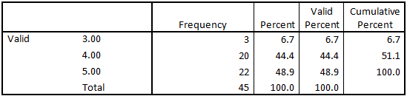
Based on table 7, it can be seen that respondents who stated strongly agree as many as 22 respondents (48.9%), agreed as many as 20 respondents (44.4%), and stated neutral as much as 3 respondents (6.7%), while respondents who disagree and very Not agree as much as 0 respondents. Based on the frequency data obtained it can be concluded that the respondents who are employees at the university of Islam (Unisma, UIN, UMM) responded strongly agree that the indicators of timeliness is a benchmark of employee performance. This can be interpreted that in general employees in Islamic universities in the city of Malang assume that good performance refers to the quality of work good.
Quantity of Work
The third indicator of employee performance is the quantity of work. The number of question items are two questions that include 1) I have mastered my job as a whole, 2) I have the working speed as expected where I work. The results of frequency distribution analysis of this indicator is presented in Table 8 as follows.
Table 8. Frequency Distribution of Work Quantities
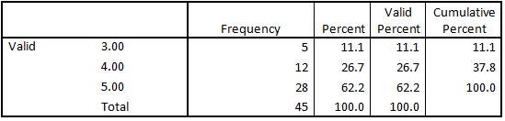
Based on table 8, it can be seen that the respondents stated strongly agree as many as 28 respondents (62.2%), agreed as many as 12 respondents (26.7%), and stated neutral as many as 5 respondents (11.1%), while respondents who disagree and strongly Not agree as much as 0 respondents.
Based on the frequency data obtained it can be concluded that the respondents who are employees at the university of Islam (Unisma, UIN, UMM) strongly agree that the quantity of good work will describe the good performance. This can be interpreted that in general employees in Islamic universities in the city of Malang assume that good performance refers to the quantity of good work.
Test Validity and Data Reliability
Validity and reliability test is done to know the extent to which the questionnaire made precise and reliable for a study. A data is said to be valid if the value is rcount> rtabel. Large rtabel can be seen in table correlation coefficient, where in this study the number of respondents as much as 45 then the value of rtabel = 0.287 with the significance level of 0.05. Meanwhile, to determine the reliability can be done by comparing the cronbach alpha > 0.6. The following is a presentation of the validity of the questionnaire items from Questionnaire 1 through 15 presented in Table 9 as follows.

Table 9. Item Validity
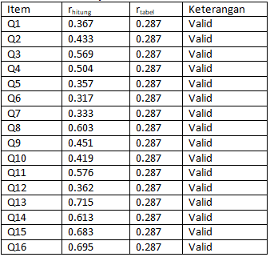
The next analysis is reliability analysis. The following is presented SPSS output reliability test results in table 10 as follows.
Table 10. Test Reliability

Reliability test results presented in table 10 can be seen that the value of cronbach’s alpha of 0.683> 0.60. This means the question items on the questionnaire are reliable to do in this study.
Classic Assumption Test Results
The classical assumption test is a prerequisite test to see data normality, data heterokedastisitas, multicoloniarity of data and autokolerasi. Test this classical assumption as a prerequisite to conduct further analysis of regression analysis. Here is an analysis of each classic assumption test using SPSS 2.3 for windows software.
Data Normality Test
Normality test conducted aims to test whether the research data conducted has a normal distribution or not. In this study the normality test was performed by conducting a one-sample analysis of kolmogorov-smirnov test in which the data was first modified in the form of unstandardized residual. The basic decision in the normality test is if the significance value is greater than 0.05 then the data is normally distributed, otherwise if the significance value is less than 0.05 then the data has No. normal distribution. The following results presented normality test analysis presented in table 11 as follows
Table 11. Data Normality Test
One-Sample Kolmogorov-Smirnov Test
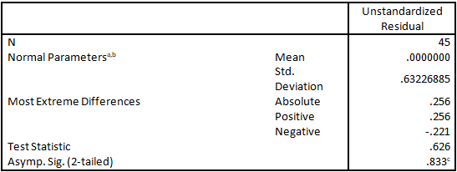
Based on table 11 it can be seen that the value of significance can be seen in the Asymp section. Sig. (2-tailled) of 0.833 greater than 0.05. This means that the data has a normal distribution. Thus, it can be explained that the regression model is feasible to be used to predict the related variables ie independent variable (work ethic of islami) and dependent variable (employee performance).
Test Data Heteroskedastisitas
This test aims to test whether in the regression model there is vanrian inequality from one observation residual to another. A good regression model is a model that does not occur heteroscedasticity. The basis of the decision is if the significance value greater than 0.05 then the conclusion is no heteroskedastisitas, otherwise if the value of significance below 0.05 then heteroscedasticity occurs. Here are the results of heteroscedasticity test analysis presented in table 12 as follows.
Table 12. Test Data Heteroskedastisitas
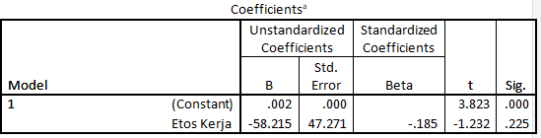
Based on the output spss 23 presented in table 12 it can be concluded that the data to be done regression test does not occur heteroskedastisitas in this case work ethic variable. It can be seen from the significance value of work ethic variable of 0.225 is greater than 0.05.

Data Multicolinearity Test
Multicolonierity test is done to test the regression model whether there is correlation between independent variables (independent), where good regersion model should not occur multicolonieritas or no correlation between independent variables. The basis for decision making can be seen in two ways: 1) looking at the tolerance and 2) looking at the VIF value. If seen from the tolerance value then the tolerance value greater than 0.10 then it means no multicolonierity to the tested data, vice versa if the tolerance value is smaller than 0.10 then it means multicolonierity. The regression model is considered to be better if the tolerance value is closer to or equal to 1 (Santoso, 2002). In addition, when viewed from the value of Variance Inflation Factor (VIF) then the VIF value must be smaller than 10 which means no multicolonierity, otherwise if the VIF value is greater than 10 then there is multicolonierity. Here are the results of multicollonearity test analysis presented in table 13 as follows.
Table 13 Multicolinearity Test
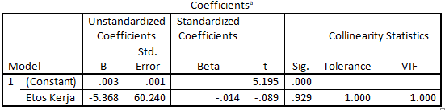
Based on the results of SPSS 23 output presented in table 13 it can be concluded that the regression model to be tested does not occur multicolonierity. It can be seen from the tolerance value of 1> 0.10. So also when viewed from the VIF value of 1 <10. Therefore it can be concluded that the regression model can be continued for analysis.
Linear Regression Analysis
The results of the analysis of classical assumption test is the test of Normality, Heteroskedastisitas, Multikolonieritas and Autokolerasi showed that all data is feasible to be tested regression analysis. This section discusses about 1) Partial influence between independent variable (X) to dependent variable (Y), 2) The effect simultaneously between independent variables (X) on the dependent variable (Y).
Influence Partially Between Independent Variable (X) to Dependent Variable (Y)
There are five hypotheses to be verified in this research. Based on the results of statistical analysis using the program SPSS 23, then the results obtained from the analysis of data as follows.

Table 14. Result of Regression Analysis Influence X on Y
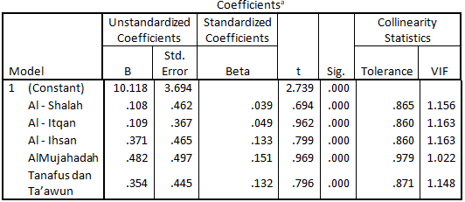
Based on the results of regression analysis presented in table 14 then the next stage of analysis is to identify the influence of work ethic on employee performance. The model of regression equation as follows.
Y = β0 + β1X1 + β2X2 + β3X3 + β4X4 + β5X5 +ei
To know the effect of X1, X2, X3, X4 and X5 to Y partially used t test and regression coefficient value which have been presented in table 14 Based on the results of regression analysis above can be presented regression equation, as follows.
Y = 10,118 + 0,108X1 + 0,109X2 + 0,371X3 + 0,482X4 + 0,354X5 +0,132
The equation shows that.
The constant (a) = 10.118, states that if the Islamic Work Ethic (X) consisting of Al-Shalah, Al-Itqan, Al-Ihsan, Al-Mujahadah, Tanafus or Ta'awun is constant, then employee performance is 10.118%
The regression coefficient X1 of 0.108 indicates if the Al - Shalah variable has increased by one unit while the other variables ie Al - Itqan (X2), Al - Ihsan (X3), Al - Mujahadah (X4), Tanafus (X5) are constant, then Employee performance (Y) will rise by 10.8%. Whereas if seen from the significance value of 0.000 <from α = 0.05. This means that Al -Shalah has a positive and significant effect on employee performance with a big influence of 10.8%.
The regression coefficient X2 of 0.109 indicates if the Al-Itqan variable has increased by one unit while the other variables ie Al - Shalah (X1), Al - Ihsan (X3), Al - Mujahadah (X4), Tanafus (X5) are constant, then Employee performance (Y) will rise by 10.9%. Whereas if seen from the significance value of 0.000 <from α = 0.05. This means Al-Iqqan affects positively and significantly to the performance of employees with a large influence of 10.9%.
The regression coefficient of X3 of 0.371 indicates if the Al-Ihsan variable has increased by one unit while the other variables ie Al - Shalah (X1), Al - Itqan (X2), Al - Mujahadah (X4), Tanafus (X5) are constant, then Employee performance (Y) will rise by 37.1%. Whereas if seen from the significance value of 0.000 < from α = 0.05. This means Al-Iqtan has a positive and significant effect on employee performance with a big influence of 37.1%.
The regression coefficient of X3 of 0.371 indicates if the Al-Ihsan variable has increased by one unit while the other variables ie Al - Shalah (X1), Al - Itqan (X2), Al - Mujahadah (X4), Tanafus (X5) are constant, then Employee performance (Y) will rise by 37.1%. Whereas if seen from the significance value of 0.000 < from α = 0.05. This means Al-Iqtan has a positive and significant effect on employee performance with a big influence of 37.1%.
The regression coefficient X5 of 0.354 indicates if the variable of Tanafus has increased by one unit while the other variables are Al - Shalah (X1), Al - Itqan (X2), Al - Ihsan (X3), Al - Mujahadah (X4) constant, then Employee performance (Y) will rise by 35.4%. Whereas if seen from the significance value of 0.000 < from α = 0.05. This means Al-Iqtan effect positively and significantly on employee performance with big influence 35,4%.
Based on the analysis of the above regression equation obtained hypothesis testing as follows.
H1: Al-Shalah or good and useful have a significant effect on employee performance. It is based on table 5.15 is known thitung 0.694 > ttable 0.679. Thus H0 rejected means Al - Shalah have a positive and significant effect on employee performance
H2: Al-Itqan or stability has a significant effect on employee performance. It is based on table 5.15 known thitung 0.962 > ttabel 0,679. Thus H0 rejected means Al - Itqan has a positive and significant effect on employee performance.
H3: Al-Ihsan or doing the best have a significant effect on employee performance. It is based on table 5.15 known thitung 0.799 > ttable 0,679. Thus H0 rejected means Al - Ihsan have a positive and significant effect on employee performance.
H4: Al-Mujahadah or hard work has a significant effect on employee performance. It is based on table 5.15 known thitung 0.969 > ttable 0.679. Thus H0 rejected means Al - Mujahadah have a positive and significant effect on employee performance.
H5: Tanafus or Ta'awun or compete and help each other to have a significant effect on employee performance It is based on table 5.15 is known thitung 0.796> ttable 0,679. Thus H0 is rejected Tanafus means a positive and significant impact on employee performance.
The Effect of Simultaneously Between Independent Variables (X) on the Dependent Variable (Y)
This section explains the simultaneous influence of Islamic work ethic variable (X) on employee performance (Y). This simultaneous test is performed by looking at the SPSS output in the anova table part (F-test). The purpose of this analysis is to see whether together independent variables affect the dependent variable. The following is a table of simultaneous effect analysis results presented in table 15 as follows.
Table 15. Results of Simultaneous Effect Analysis

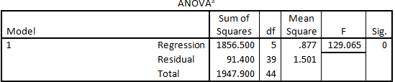
Based on table 15, it can be seen that the value of Sig. F of 0.000 < PValue = 0.05. This can be interpreted that the independent variables of Islami Work ethic consisting of Al-Shalah, Al - Itqan, Al - Ihsan, Al - Mujahalah and Tanafus simultaneously affect Employee Performance variables. While for big influence simultaneously presented in table 16 as follows.
Table 16. Simultaneous Influence
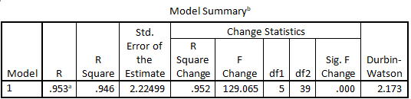
Based on table 16, it can be seen that the influence of the independent variables is Islamic Work Ethic consisting of Al-Shalah, Al - Itqan, Al - Ihsan, Al - Mujahalah and Tanafus simultaneously affect Employee Performance variable of 0.953 or 95.3% Is 0.946 or 94.6%. This means simultaneously the Islamic Work Ethic consisting of Al-Shalah, Al - Itqan, Al - Ihsan, Al - Mujahalah and Tanafus simultaneously affect Employee Performance variables.
- Conclusion
Based on the results of analysis related to the purpose of research and problem formulation in this study, it can be drawn some conclusions as follows:
Al-Shalah (good and beneficial) have a positive and significant impact on employee performance. This means that the better Al - Shalah in this case employees who have good relationships with colleagues and superiors will make better employee performance. Al-Itqan (quality work) has a positive and significant impact on employee performance. This means that quality work will determine better employee performance. Al-Ihsan (the best work) has a positive and significant impact on employee performance. This means that the ability possessed by the employee is used fully to complete the task given and it will affect employee performance. The better the work that can be completed the employee the better the performance of employees. Al-Mujahadah (hard work) has a positive and significant impact on employee performance. This means that employees who have a good work ethic or employees who work hard in completing the task will make better employee performance. Tanafus or Ta'awun (competing and helping each other) have a positive and significant impact on employee performance. This means that attitudes to compete with each other in a healthy manner and have a mutual character or culture help each other will make the employee performance better. For example, when an employee cannot complete the task then the other employees will help to complete the task, so the task can be completed properly.
To the next researcher is recommended to conduct further research with different research methods with this research in order to get in-depth data so as to obtain a more comprehensive picture. In addition, the researcher is expected to be able to control the research sample and suggested to consider several other variables that contribute in affecting employee performance.
- Reference
W. Rokhman, “The Effect of Islamic Work Ethics on Work Outcomes,” EJBO Electron. J. Bus. Ethics Organ. Stud., vol. 15, Jan. 2010.
E. Haroon, C. L. Raison, and A. H. Miller, “Psychoneuroimmunology meets neuropsychopharmacology: Translational implications of the impact of inflammation on behavior,” Neuropsychopharmacology, vol. 37, no. 1, pp. 137–162, 2012, doi: 10.1038/npp.2011.205.
M. Usman, “Islamic Work Ethic and Public Sector Innovation: Entrepreneurial Orientation as a Moderator,” Int. J. Bus. Technopreneursh., vol. 7, no. 2, pp. 203–212, 2017.
F. A.-Z. Sami and A. Abdul Rahim, “ETHICS & VALUES IN CONSTRUCTION INDUSTRY FROM ISLAMIC PERSPECTIVE,” Plan. MALAYSIA, vol. 15, no. 1 SE-Article, May 2017, doi: 10.21837/pm.v15i1.248.
G. Murtaza, M. Abbas, U. Raja, O. Roques, A. Khalid, and R. Mushtaq, “Impact of Islamic Work Ethics on Organizational Citizenship Behaviors and Knowledge-Sharing Behaviors,” J. Bus. Ethics, vol. 133, no. 2, pp. 325–333, Feb. 2016.
Y. Ulman, “Social Ethics,” 2015, pp. 1–11.
K. Kurniati, S. Basalamah, A. Halim, and A. Syahid, “the Effect of Islamic Work Ethic, Competence and Motivation on the Performance of State Madrasah Aliyah Teachers in South Sulawesi,” J. Diskurs. Islam, vol. 9, no. 3, p. 368, 2021, doi: 10.24252/jdi.v9i3.21451.
A. Syarif, A. Rahmawati, and M. Fasa, “The Effect of Islamic Work Ethic and Productivity on Work Quality Through The Employee Performance,” Rev. Islam. Econ. Financ., vol. 2, pp. 40–52, Dec. 2019, doi: 10.17509/rief.v2i1.22375.
H. E. Chanzanagh and M. Akbarnejad, “The Meaning and Dimensions of Islamic Work Ethic: Initial Validation of A Multidimensional IWE in Iranian Society,” Procedia - Soc. Behav. Sci., vol. 30, pp. 916–924, 2011, doi: https://doi.org/10.1016/j.sbspro.2011.10.178.
K. Hayati and I. Caniago, “Islamic Work Ethic: The Role of Intrinsic Motivation, Job Satisfaction, Organizational Commitment and Job Performance,” Procedia - Soc. Behav. Sci., vol. 65, no. ICIBSoS, pp. 272–277, 2012, doi: 10.1016/j.sbspro.2012.11.122.
G. Sudarmanto, “Teologi multikultural,” Ed. by Dina Elisabeth Latumahina. 1st ed. Batu Dep. Multi-Media YPPII Batu, 2014.
A. Ali and A. Al-Owaihan, “Islamic work ethic: A critical review,” Cross Cult. Manag. An Int. J., vol. 15, pp. 5–19, Feb. 2008, doi: 10.1108/13527600810848791.
W. Norhasniah and W. N. Wan Husin, “Work Ethics from the Islamic Perspective in Malaysia,” Eur. J. Soc. Sci., vol. 29, Feb. 2012.
R. Rose, “Examining the link between Islamic work ethic and innovation capability,” J. Manag. Dev., vol. 29, pp. 79–93, Jan. 2010, doi: 10.1108/02621711011009081.
N. Siddiqui, S. Hameed, R. Sattar, and B. Eneizan, “Islamic Work Ethics Impact on Employee Performance,” pp. 1–7, Aug. 2019.
A. Abbasi, “THE IMPACT OF ISLAMIC WORK ETHICS ON EMPLOYEE PERFORMANCE: TESTING TWO MODELS OF PERSONALITY X AND PERSONALITY Y.,” Jan. 2013.
S. N. bin Salahudin, S. S. binti Baharuddin, M. S. Abdullah, and A. Osman, “The Effect of Islamic Work Ethics on Organizational Commitment,” Procedia Econ. Financ., vol. 35, pp. 582–590, 2016, doi: https://doi.org/10.1016/S2212-5671(16)00071-X.
Ridwan, “PEMBERDAYAAN ETOS KERJA MASYARAKAT DALAM PERSPEKTIF AL-QUR’AN,” 2019, doi: https://doi.org/10.15548/amj-kpi.v0i0.1265.
A. Sodiq, “Pengaruh Etika Kerja Islam, Kepemimpinan Transformasional Dan Motivasi Kerja Terhadap Kinerja Karyawan Di Kjks Bmt Logam Mulia Grobogan,” BISNIS J. Bisnis dan Manaj. Islam, vol. 6, no. 1, p. 118, 2018, doi: 10.21043/bisnis.v6i1.3700.
A. Mahfoudh, M. Salleh, and H. Din, “Contemporary Issues and Development in the Global Halal Industry,” Contemp. Issues Dev. Glob. Halal Ind., pp. 381–390, 2017, doi: 10.1007/978-981-10-1452-9.
M. Qasim, M. Irshad, M. Majeed, and S. T. H. Rizvi, “Examining Impact of Islamic Work Ethic on Task Performance: Mediating Effect of Psychological Capital and a Moderating Role of Ethical Leadership,” J. Bus. Ethics, 2021, doi: 10.1007/s10551-021-04916-y.
F. N. Nasution and A. Rafiki, “Islamic work ethics, organizational commitment and job satisfaction of Islamic banks in Indonesia,” RAUSP Manag. J., vol. 55, no. 2, pp. 195–205, 2020, doi: 10.1108/RAUSP-01-2019-0011.
M. A. Abbas and T. O. Kowang, “Impact of Ethical Leadership and Islamic Work Ethics on Employee Commitment and Job Satisfaction,” J. Res. Psychol., vol. 2, no. 2, pp. 47–58, 2020, doi: https://doi.org/10.31580/jrp.v2i2.1601.
T. Wijaya, “Metodologi penelitian ekonomi dan bisnis teori dan praktik,” 2013.

